Project 1 Documentation

This project is a gym tracker that is designed to allow you to see from a calendar view your progress. These sketches are the basic design work put into the project: 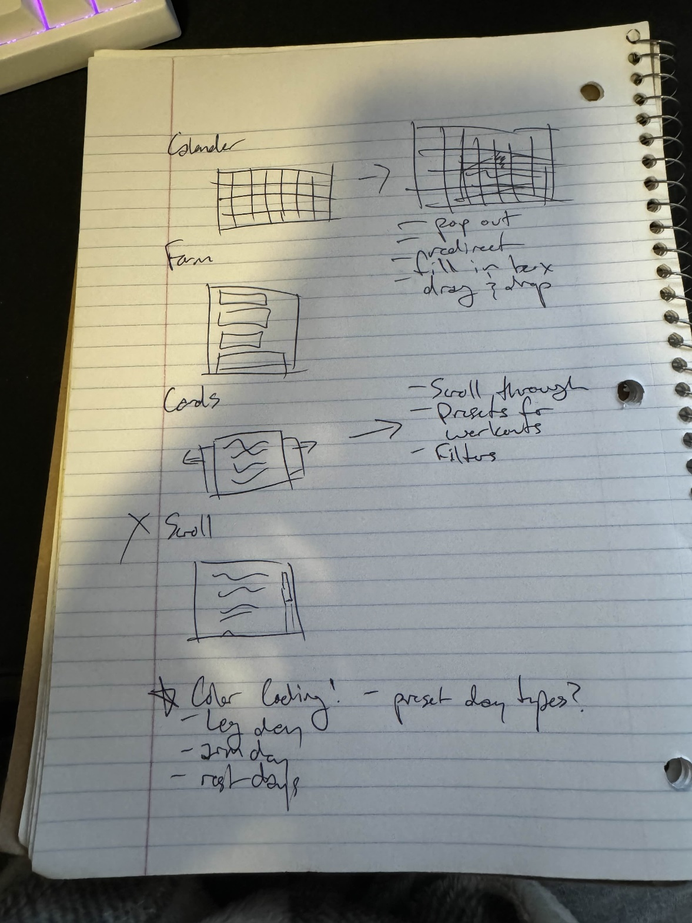

The site is designed so that you can click on a date on the calendar an a form will appear that allows you to input simple information about what workouts you did including what exercises and your reps/sets.

Calendar home page: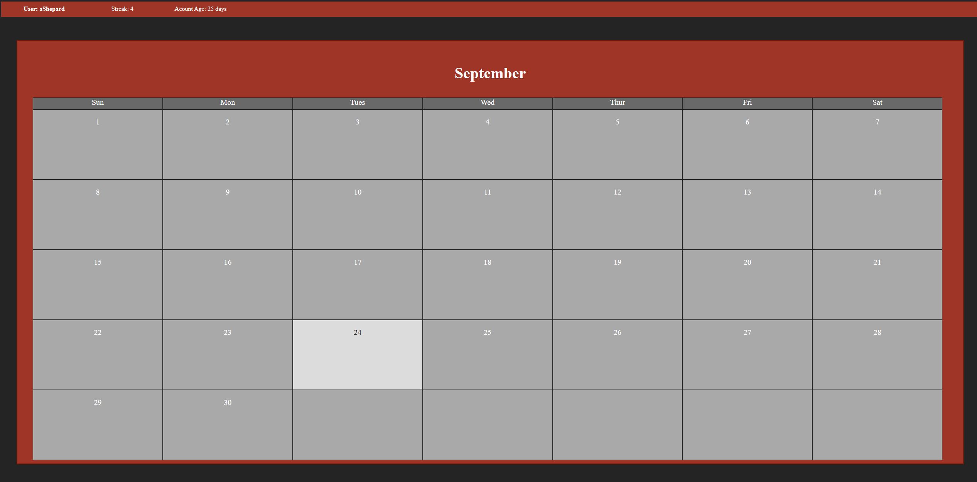

Form Overlay:

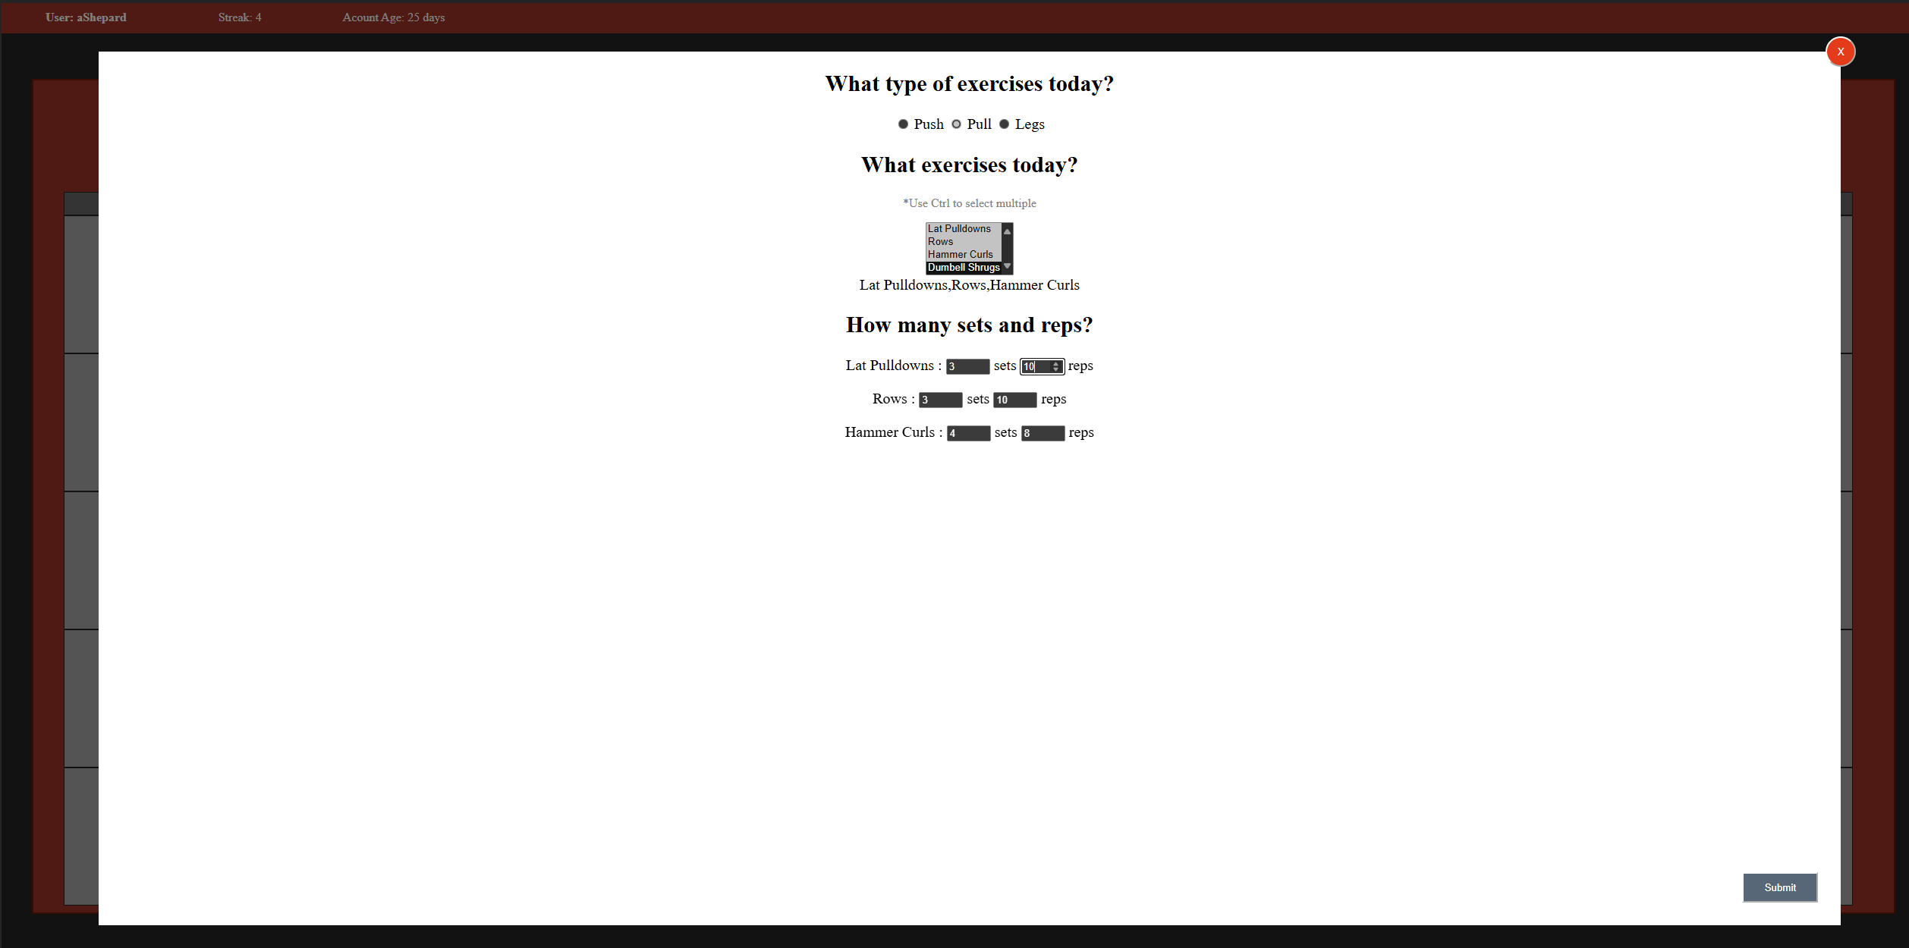

I did not use any AI for this project, but there was a lot of referencing stack overflow while debugging.

In the future for this project, I would implement more questions and a method to save past workouts as defaults to minimize user inputs needed for faster use. I attempted to save user form responses to a json, but failed to debug it in time, so that is another future improvement that would allow for much more of the proper functionality to be implemented.

[ShepardAnthony/UI-Portfolio (github.com)](https://github.com/ShepardAnthony/UI-Portfolio)